CAD Design Similarity Search
A GenAI-Based Approach to Engineering Design Reuse
Vishal Prabu | October 2026

Project Overview
This project is a proof of concept demonstrating that, given a CAD part, an AI system can automatically retrieve the most structurally similar existing designs from a repository, without relying on filenames, folder structure, or manual search. It is a self-directed technical exploration aligned with the Industrials team's broader direction on applying GenAI to the engineering design lifecycle, built independently using open-source data and tools to establish feasibility ahead of any client-specific engagement. The proof of concept now also includes part size properties, an optional size filter, search with a newly supplied STEP file, and a simple web interface.

Objectives
- Establish whether geometric deep learning can support a practical design-reuse and search capability for CAD repositories.
- Build and validate an end-to-end proof of concept: CAD part in, ranked list of similar existing designs out.
- Create a reusable technical foundation (data pipeline, embedding generation, retrieval) that can extend to adjacent engineering-design use cases beyond reuse search.
- Make the capability tangible through a simple interface that supports size-aware filtering and search with a newly supplied part.

Why This Matters
Engineering teams frequently redesign components that closely resemble something already built, simply because there is no efficient way to search a design repository by shape or feature similarity rather than by filename or manual browsing. Unnecessary part duplication is a well-documented cost driver in manufacturing organizations, adding avoidable design, tooling, and inventory overhead. This capability directly targets that gap, and reflects the kind of design-reuse and validation problem increasingly relevant across engineering-heavy client accounts. This PoC proves the underlying technique works end-to-end on real CAD geometry, ahead of applying it to any specific client repository.

Technical Approach
The pipeline combines three open-source components, each addressing one stage of turning a raw CAD file into a searchable, comparable representation:
- Geometry parsing (OpenCascade / occwl): reads STEP files, the neutral CAD exchange format supported by virtually all major CAD systems, and extracts the underlying B-Rep topology, the exact faces, edges, and surface relationships that define the part.
- Embedding generation (BRepNet): a pretrained deep learning model that operates directly on B-Rep topology, rather than approximating shapes as meshes or point clouds. It converts each design's geometry into a compact numeric “fingerprint” (84 numbers per part, averaged from per-face representations) capturing its structural and feature composition.
- Similarity retrieval (FAISS): an open-source vector search library that indexes these fingerprints and, given a query part, returns the closest matches ranked by similarity distance. Exact (brute-force) search is used, which is sufficient at the current scale of 500 designs.
All components are open-source, and the pipeline operates on STEP files, making the underlying approach broadly portable across different clients' native CAD environments.
BRepNet and occwl were written for older software versions. Running them on current Python, PyTorch and PyTorch Lightning required a small set of patches (API and checkpoint-loading changes, per-file error handling and a batch embedding script). occwl 3.0.0 is built from source because it is not published on PyPI. The patches are listed in the project reference deck.

Capabilities
- Search by an existing design or by a newly supplied STEP file. A new part is embedded with the same pipeline, and the index is not modified.
- Part properties shown with every match: bounding-box size (largest to smallest, so orientation does not matter), volume, surface area and face count, computed with occwl.
- Optional size filter: keeps only matches whose sorted bounding-box dimensions are each within a tolerance (default ±20%) of the query. The whole index is searched, and the survivors are ranked by similarity distance.
- Simple web interface (Streamlit) combining the above, with thumbnails, distances and properties for the top five matches.

Results to Date
- Built and validated the full pipeline end-to-end on 500 real mechanical CAD designs (Autodesk Fusion 360 Gallery dataset).
- Retrieval correctly identifies structurally similar parts even when their exact dimensions differ substantially. See Examples 1 to 3 below.
- Re-embedding designs that are already indexed reproduces the stored embeddings to within about 1e-7, confirming that index build and live queries are consistent.
- The size filter and new-part search work end-to-end.
- Match quality for more geometrically complex parts is currently more mixed. Mean pooling of per-face representations is the suspected cause, but this has not yet been confirmed, and it is the immediate technical focus.
- Current results demonstrate feasibility; adapting this to a specific client's CAD repository would require validation against that client's own design and reuse criteria.

Example Retrieval Results
Example 1: validated result
Query Part | Match 1 | Match 2
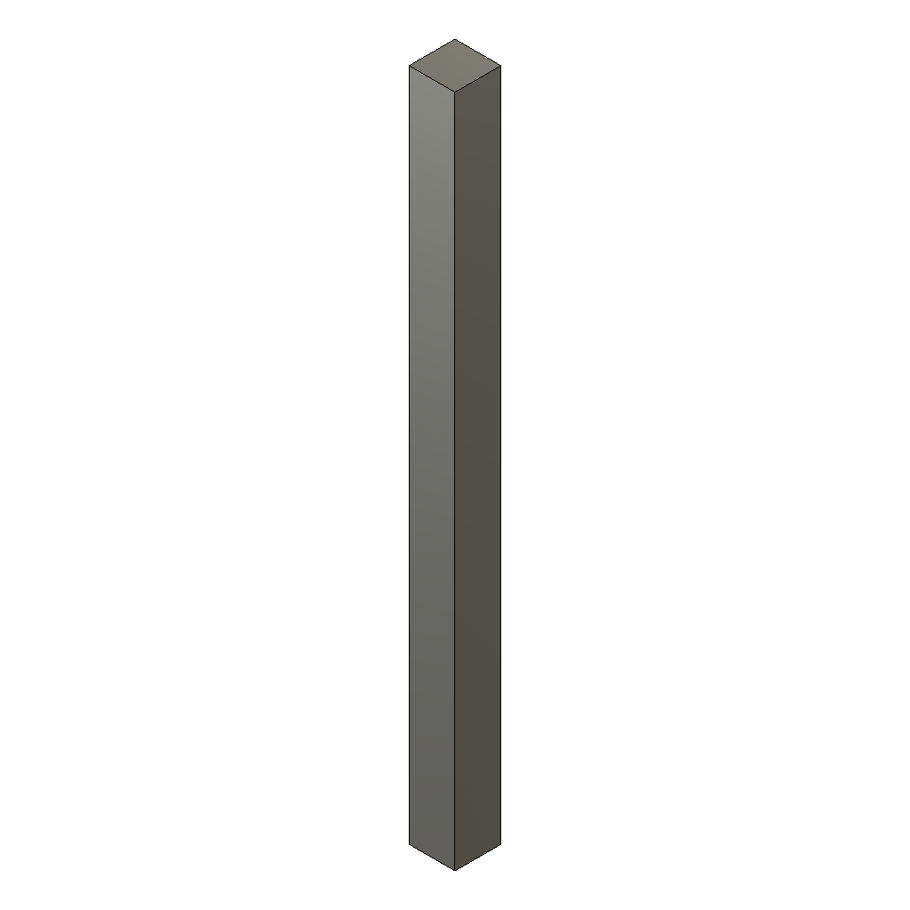  Query design | 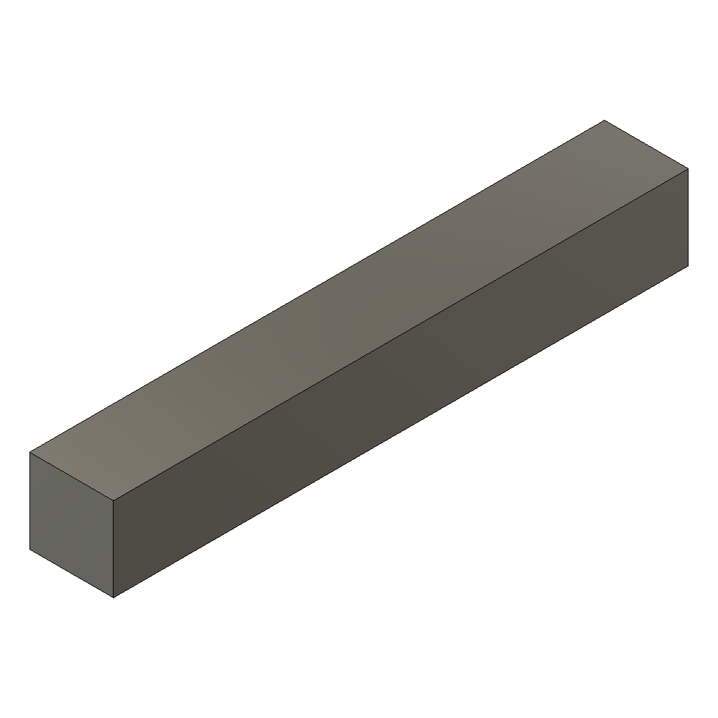  Distance: 0.0397 | 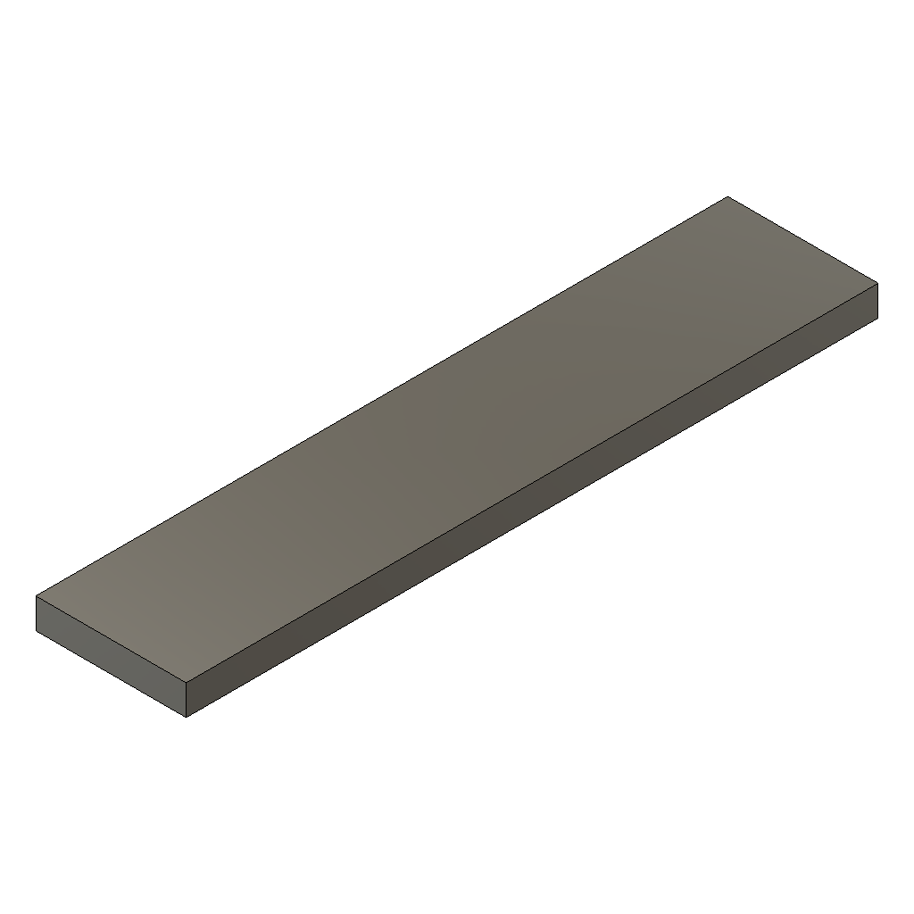  Distance: 0.0630
Match 1 in Example 1 is a thick bar (1100 × 75 × 75 mm) retrieved for a thin column (130 × 19 × 19 mm): feature composition matches, size does not. Distances are squared Euclidean values; smaller means closer.
Example 2:
Query Part | Match 1 | Match 2
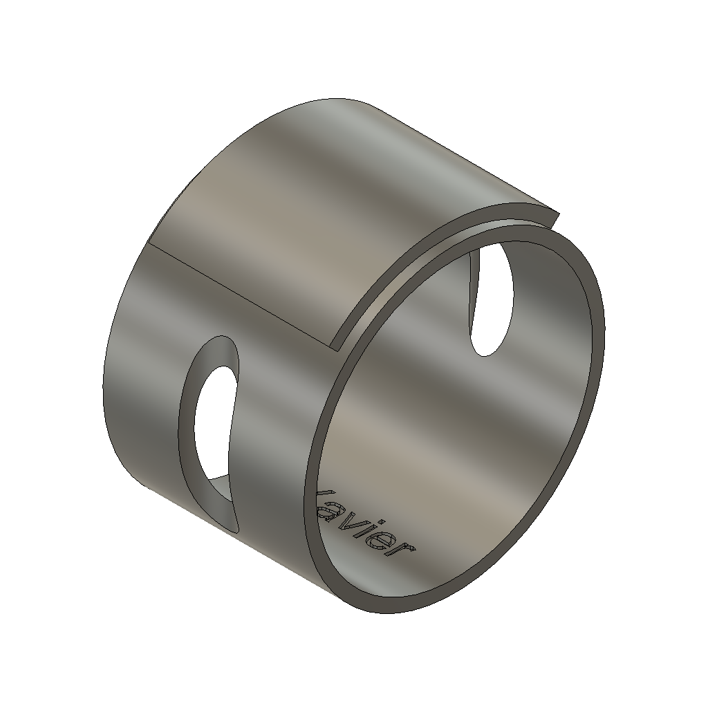  Query design | 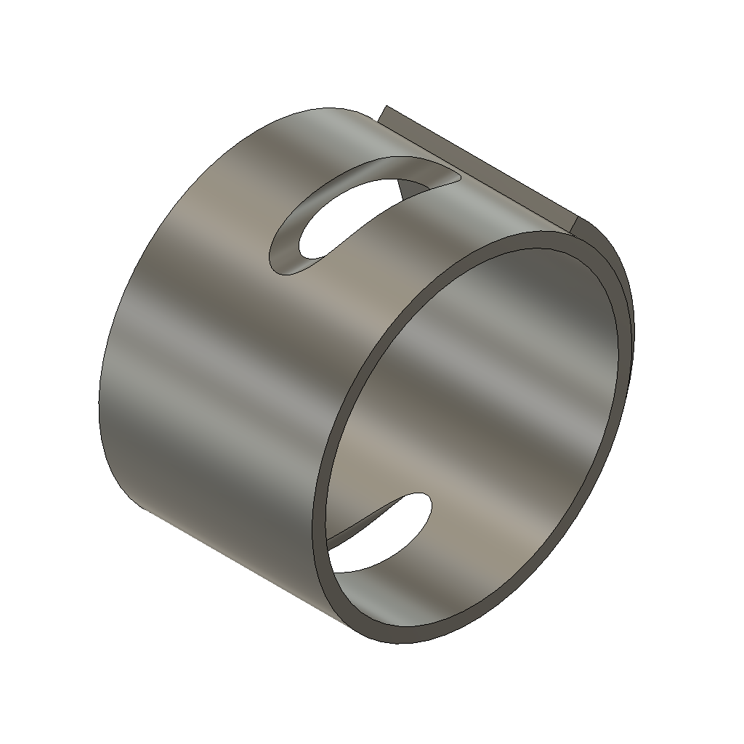  Distance: 0.2280 | 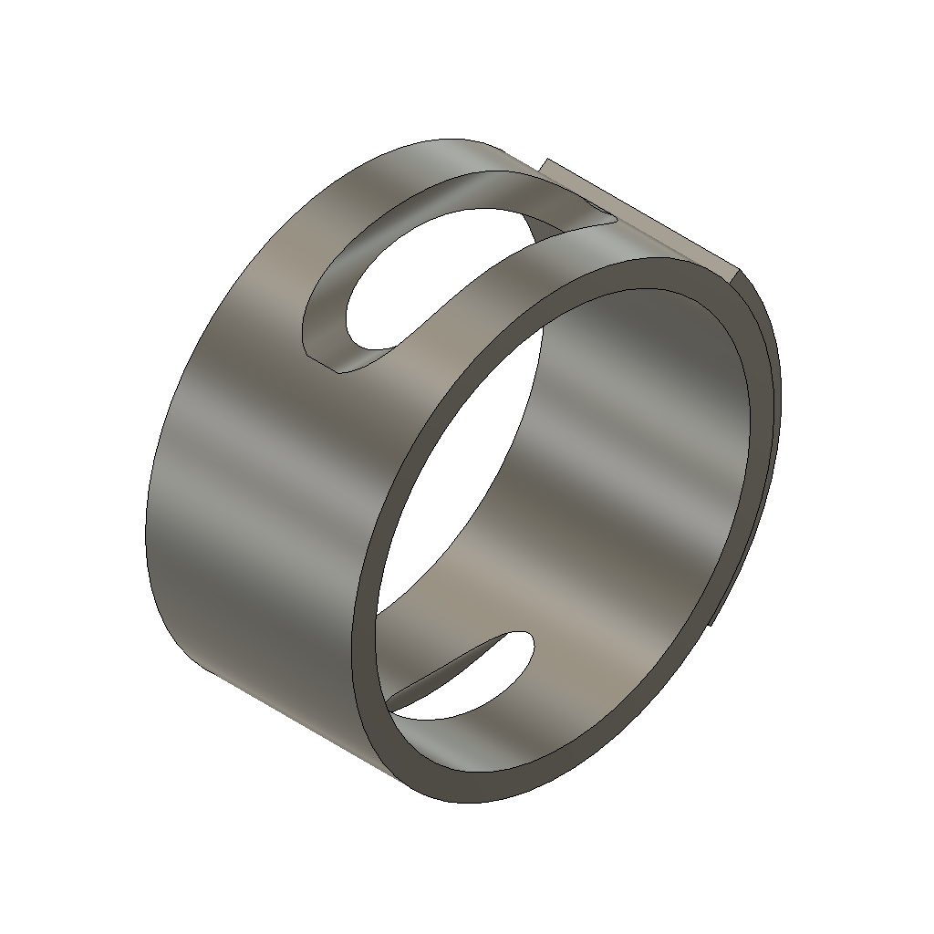  Distance: 0.2484
Example 3:
Query Part | Match 1 | Match 2
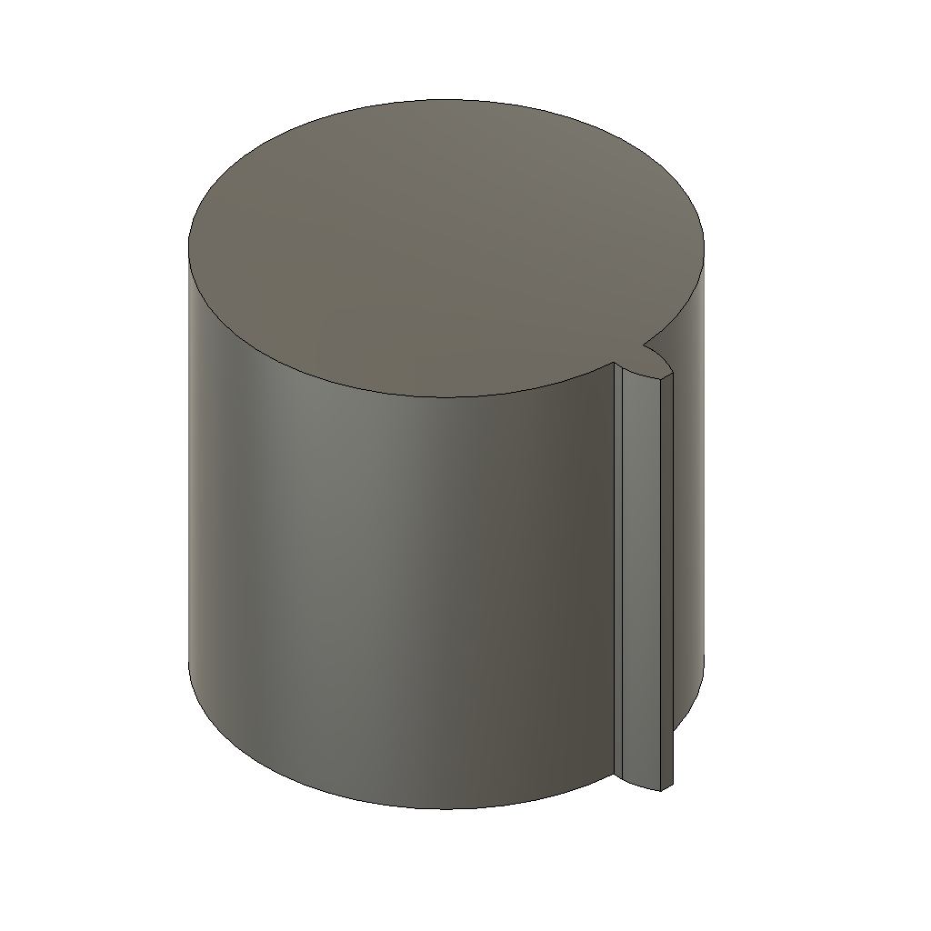  Query design | 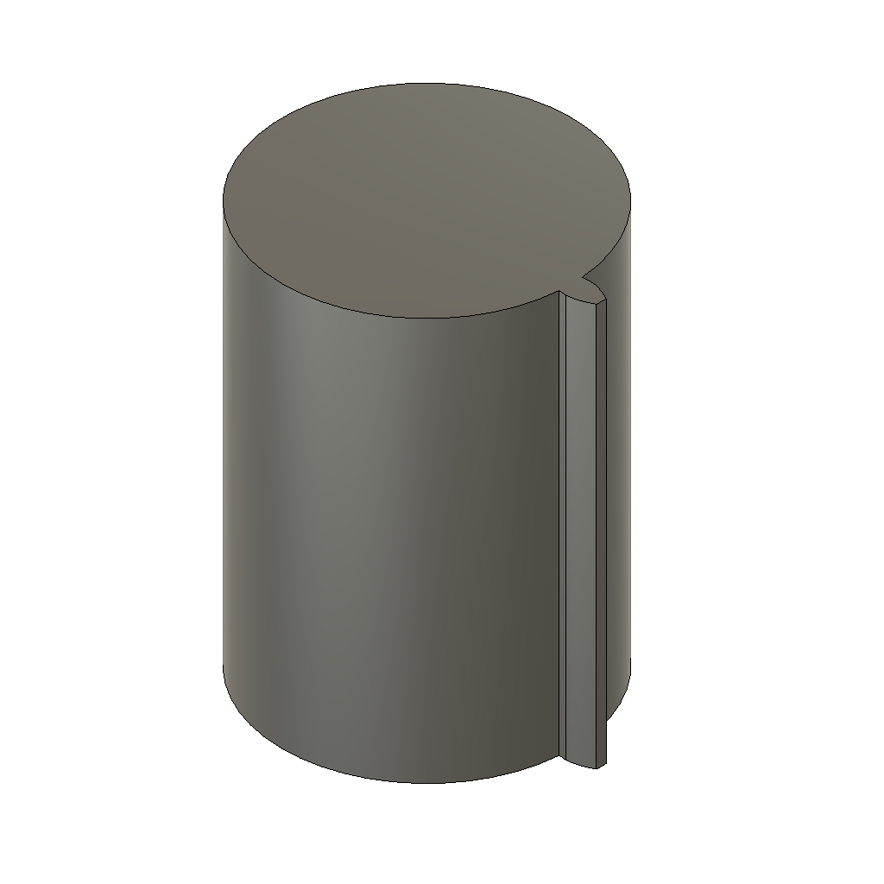  Distance: 0.0333 | 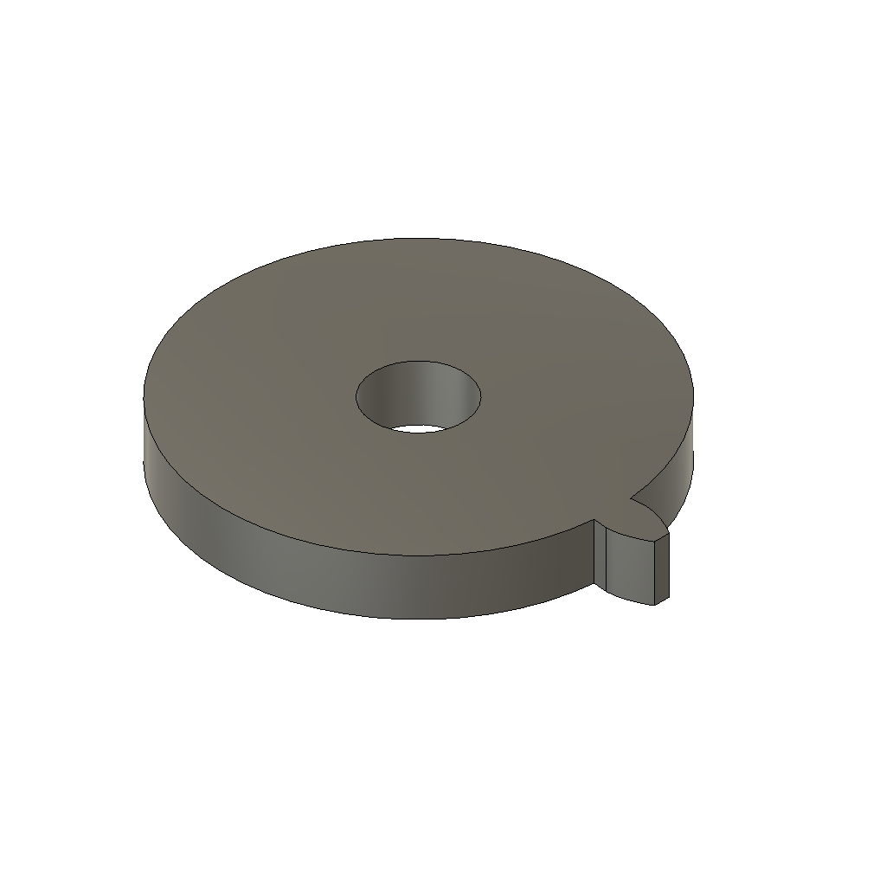  Distance: 0.1201

Known Limitations
- Similarity reflects feature composition rather than size, so a thin column can match a thick bar. The size filter addresses this, but size-compatible matches are often far from the query in embedding space.
- A STEP file that loads but is malformed can still crash the embedding step. Unreadable files are detected and rejected before embedding.
- The index covers 500 designs from a dataset licensed for non-commercial research use only; client-facing or commercial use requires a separate licence review. A few designs are authored at extreme scales, so sizes are in model units (millimetres for most).

Value for Engineers
- Lets engineers check for a reusable existing design before starting from scratch, shortening design cycles.
- Searches by actual geometric and structural similarity, not filename, folder location, or tribal knowledge of who worked on something similar.
- Format-agnostic foundation (STEP-based) makes the approach broadly applicable across clients' differing native CAD systems.
- The same technical building blocks extend naturally to adjacent problems, such as automated manufacturability screening, without starting over. A companion proof of concept on machining-feature recognition already reuses the same BRepNet backbone.

Next Steps
- Broaden validation across a larger and more complex sample of designs, with a labelled benchmark to quantify retrieval quality.
- Investigate the weaker results on complex parts, including alternatives to mean pooling.
- Keep the repository self-contained for handover: environment definition, patched third-party code and the patch list under version control.
- Apply the same technical foundation to other use cases, such as the companion manufacturability / feature screening proof of concept.
- Assess what would be required to adapt this approach to a specific client's CAD data and repository.

